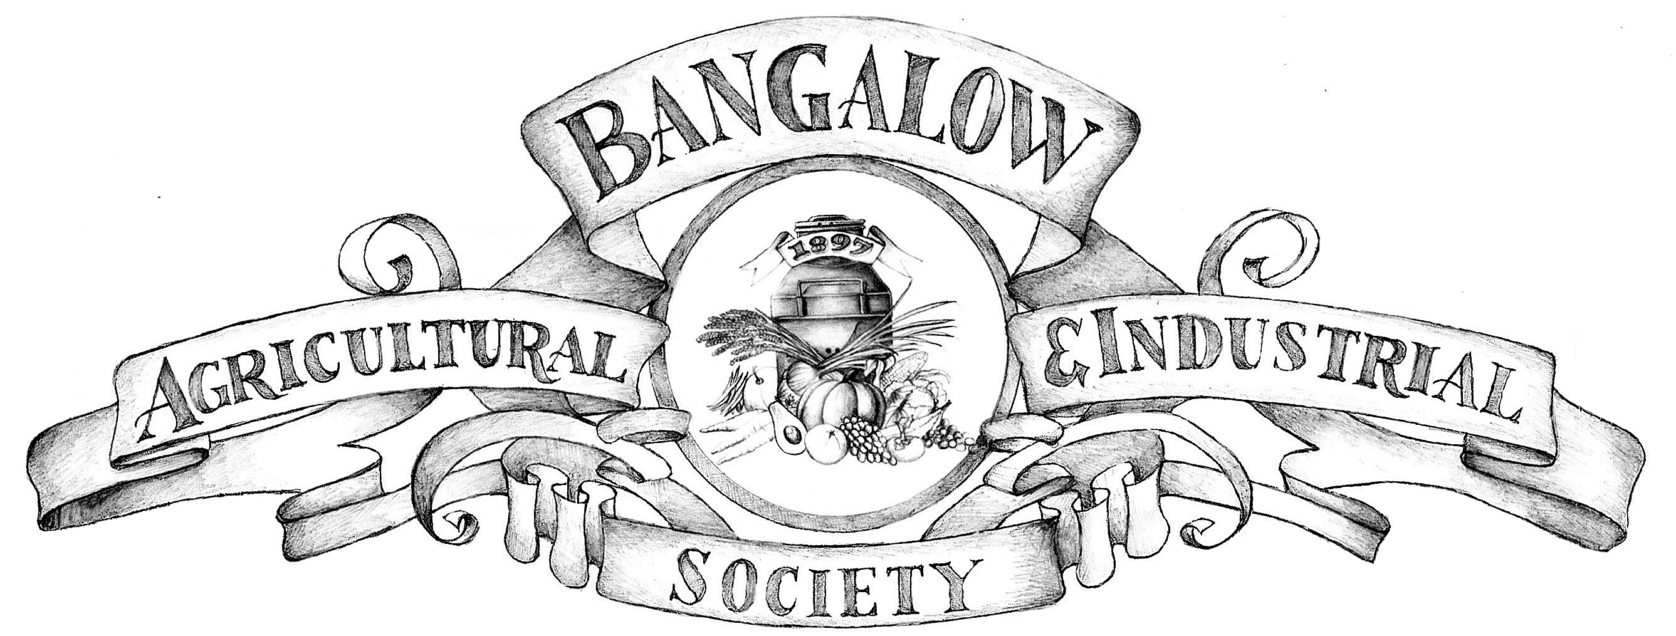

**JOHNE’S DISEASE REGULATIONS**

**DECLARATION BY EXHIBITOR / EXHIBITORS AGENT**

I

of

being the Exhibitor or the duly authorized exhibitor’s agent of the cattle

(goats/alpaca) entered in the 2022 exhibition declares that:

*1.* The stock has come from a herd & property where Johne’s Disease has not been known or existed in the last five years.

*2.* None of the animal has been introduced into this herd or property from a herd or property where

I have any reason to believe Johne’s Disease is known or suspected to exist.

*3.* None of the animals entered have been on a property or in a herd where I have reason to believe

Johne’s Disease is known or suspected to exist.

*4.* I undertake to advise the Chairman of the Agricultural Society Committee if there is any new information which would alter the above.

*5.* I acknowledge the Agricultural Society relies on the above and I accept personal responsibility for its truth and accuracy.

SIGNATURE:

DATE :

I

being the RLPB Veterinarian certify that I have no reason to doubt the declaration above in respect of the history of Johne’s Disease.

SIGNED

DATE

Due to a recommendation from the Agricultural Societies Council of NSW, all cattle attending the Bangalow Show must provide a copy of the pestivirus lab report for each animal entered for competition prior to entry being accepted.